

Internet Programming

Midterm 1

Issa Haddad

47102

March 27, 2016

Q1)

PHP file

<?php

// getting the xml file

$xml=simplexml_load_file("trueorfalse.xml");

// get in this loop if the question type is either multichoice or truefalse

if ($xml['type']=="multichoice" or $xml['type']=="truefalse") {

//print question name and the question itself

echo "A ".$xml['type']. " " . $xml->name->text. "<br><br>";

echo $xml->questiontext->text."<br>";

//displaying answers

foreach($xml->answer as $details) {

echo "<input type='radio' name='multi' value ='$details->text'>".$details->text."<br/>";

}

}

// get in this loop if the question type is a shortanswer

else if($xml['type']=="shortanswer")

{

//displaying textbox for writing your answer

echo "A ".$xml['type']. " " . $xml->name->text. "<br><br>";

echo $xml->questiontext->text."<br>";

echo "Answer: <input type='text' id = 'ans' name='ans'>";

}

// get in this loop if any other question type is given

else

{

echo "This type of question is not supported";

}

?>

Multiple choice xml

<question type="multichoice">

<name>

<text>IQ test</text>

</name>

<questiontext format="html">

<text>Kimberly makes $20 per hour and works for 20 hours each week. How much does she make in a week?</text>

</questiontext>

<answer fraction="100">

<text>$400</text>

<feedback><text>Correct!</text></feedback>

</answer>

<answer fraction="0">

<text>$50</text>

<feedback><text>Ooops!</text></feedback>

</answer>

<answer fraction="0">

<text>$200</text>

<feedback><text>Ooops!</text></feedback>

</answer>

</question>

True or false xml

<question type="truefalse">

<name>

<text>Sea World test</text>

</name>

<questiontext format="html">

<text>The blue whale, the world's largest animal, has teeth 12 inches long.</text>

</questiontext>

<answer fraction="0">

<text>true</text>

<feedback><text>Ooops!</text></feedback>

</answer>

<answer fraction="100">

<text>false</text>

<feedback><text>Correct!</text></feedback>

</answer>

</question>

Short answer xml

<question type="shortanswer">

<name>

<text>Geaography test</text>

</name>

<questiontext format="html">

<text>What is the biggest country in the world?</text>

</questiontext>

<answer fraction="100">

<text>Russia</text>

<feedback><text>Correct!</text></feedback>

</answer>

<answer fraction="100">

<text>russia</text>

<feedback><text>Correct!</text></feedback>

</answer>

<answer fraction="100">

<text>RUSSIA</text>

<feedback><text>Correct!</text></feedback>

</answer>

</question>

Screenshots for each xml

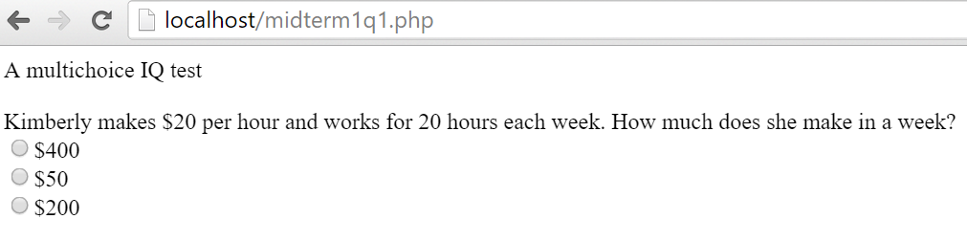

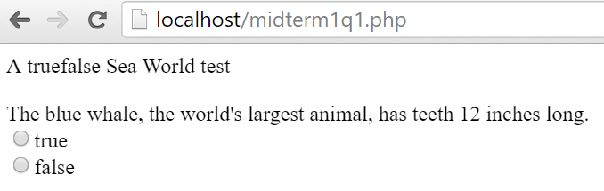

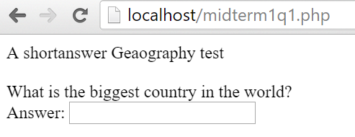

Q2)

JavaScript file

<!DOCTYPE html>

<html>

<body>

<script type="text/javascript">

// calling the function for ajax

Result();

// a variable i use to store inofrmation whether the answer is correct or not

var correct;

// getting data from php in forms of html tags

function Result()

{

var xmlhttp = new XMLHttpRequest();

xmlhttp.onreadystatechange = function(){

if (xmlhttp.readyState == 4 && xmlhttp.status == 200) document.write(xmlhttp.responseText);

}

xmlhttp.open("GET", "mid1q2php.php", true);

xmlhttp.send();

}

// this functions handles calculation of result for multichoice and trufalse questions (called from php submit tag which i get using ajax)

function seeResult()

{

// the id is equivalent to the fraction of the particular answer in xml (either 0 or 100)

if(document.getElementById('100').checked) {

window.alert("your answer is correct");

correct = true;

}else {

window.alert("your answer is wrong");

correct = false;

}

sendResult();

}

// this function handles calculation of result for shortanswer (called from php submit tag which i get using ajax)

function seeResultSA()

{

// for shortanswer multiple solutions are accepted, I check if the input text field matches any of the correct possible answers

var all = document.getElementsByTagName("sa");

for(var i = 0, max = all.length; i < max; i++)

{

if(all[i].getAttribute("id")==document.getElementById("ans").value)

{

window.alert("your answer is correct");

correct = true;

}

}

if(correct!=true)

{

window.alert("your answer is false");

correct = false;

}

sendResult();

}

//called to send result back to php server

function sendResult()

{

var xmlhttp = new XMLHttpRequest();

xmlhttp.open("GET", "mid1q2php.php?result=" + correct, true);

xmlhttp.send();

}

</script>

</body>

</html>

PHP file

<?php

// getting the xml file

$xml=simplexml_load_file("multi.xml");

// get in this loop if the question type is either multichoice or truefalse

if ($xml['type']=="multichoice" or $xml['type']=="truefalse") {

//print question name and the question itself

echo "A ".$xml['type']. " " . $xml->name->text. "<br><br>";

echo $xml->questiontext->text."<br>";

//displaying answers

foreach($xml->answer as $details) {

echo "<input type='radio' id=" .$details['fraction'] . " name='multi' value ='$details->text'>".$details->text."<br/>";

}

echo "<input type='submit' onclick='seeResult()'>";

}

// get in this loop if the question type is a shortanswer

else if($xml['type']=="shortanswer")

{

//displaying textbox for writing your answer

echo "A ".$xml['type']. " " . $xml->name->text. "<br><br>";

echo $xml->questiontext->text."<br>";

//create nodes in javascript with short answer possible answers

foreach($xml->answer as $details) {

echo "<SA type='hidden' id=". $details->text .">";

}

echo "Answer: <input type='text' id='ans' name='ans'>";

echo "<input type='submit' onclick='seeResultSA()'>";

}

// get in this loop if any other question type is given

else

{

echo "This type of question is not supported";

}

//get reult back after processing from javascript

$value = $_REQUEST["result"];

?>

Screenshots for each xml file

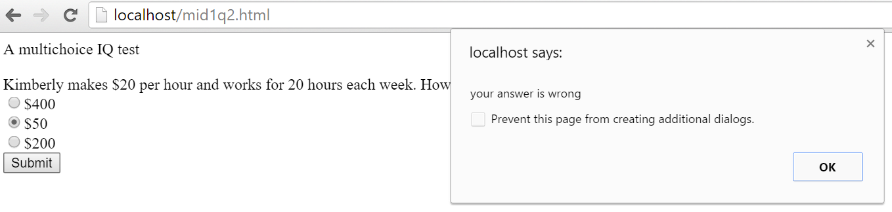

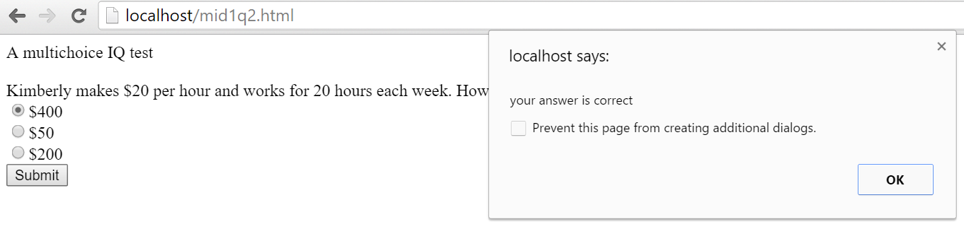

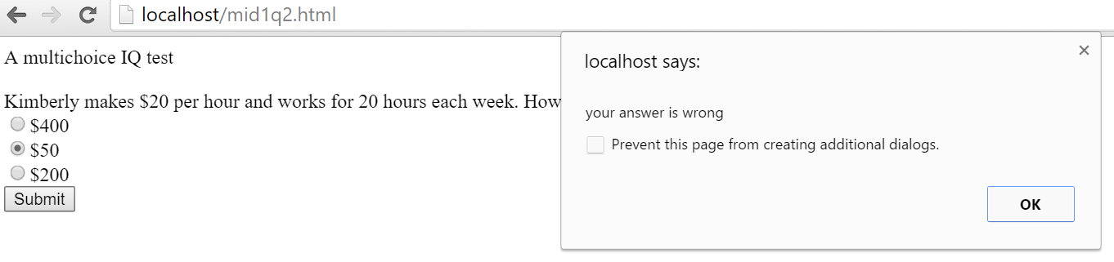

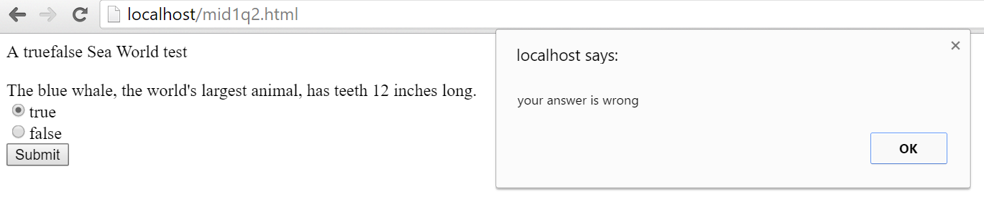

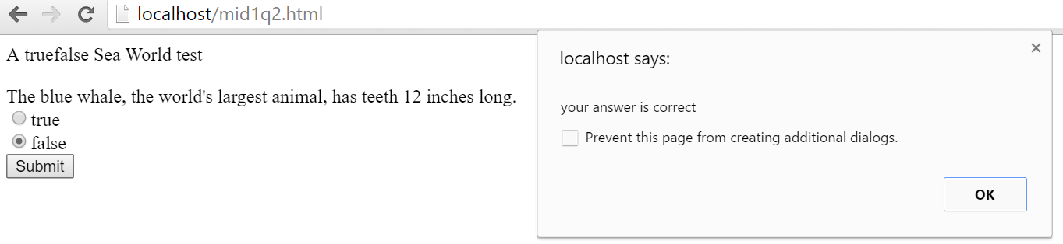

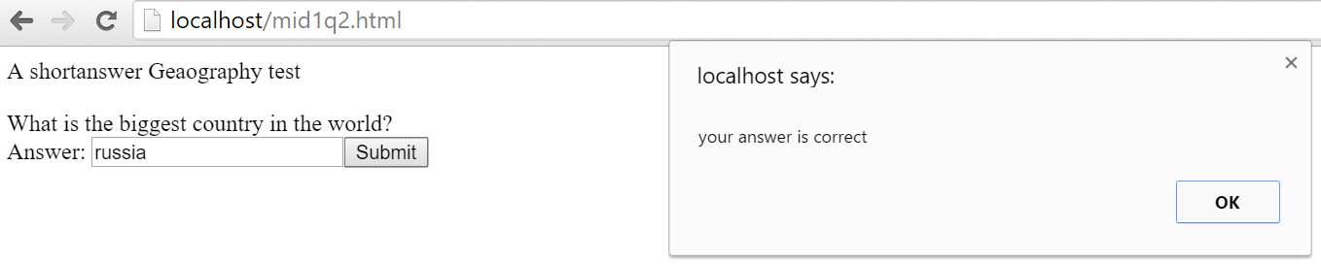

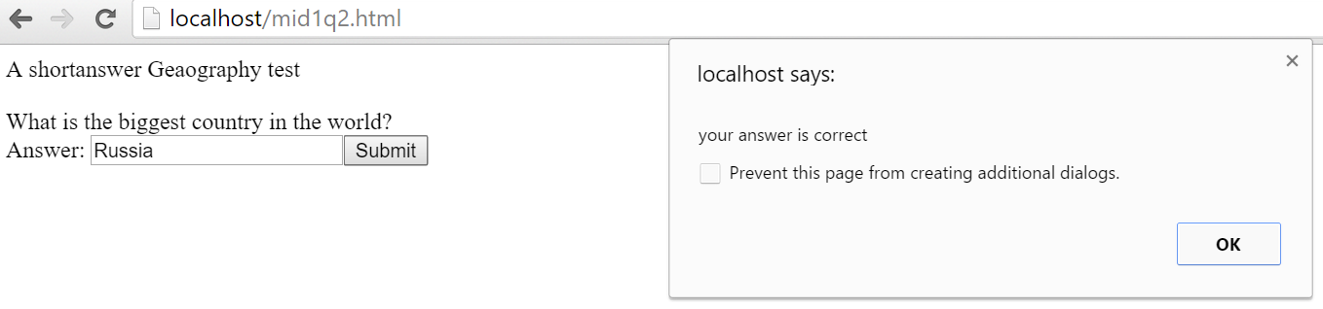

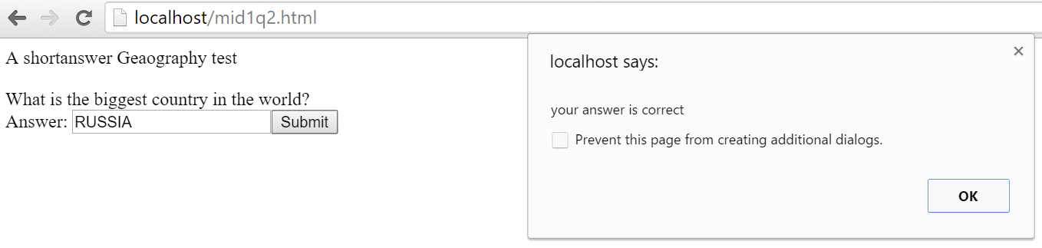

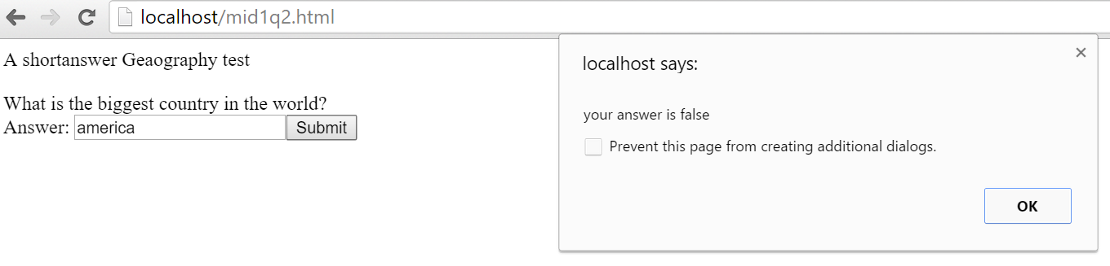

Q3a)

First question part: PHP file

<?php

// getting the json file

$data = file_get_contents('multiJSON.json');

$json = json_decode($data,true);

// get in this loop if the question type is either multichoice or truefalse

if ($json['Question'][0]['type']=="multichoice" or $json['Question'][0]['type']=="truefalse") {

//print question name and the question itself

echo "A ".$json['Question'][0]['type']. " " . $json['Question'][0]['name'] . "<br><br>";

echo $json['Question'][0]['questiontext']."<br>";

//displaying answers

foreach($json['Question'][0]['answers'] as $item) {

echo "<input type='radio' name='multi' value =".$item['text'] .">".$item['text']."<br/>";

}

}

// get in this loop if the question type is a shortanswer

else if($json['Question'][0]['type']=="shortanswer")

{

//displaying textbox for writing your answer

echo "A ".$json['Question'][0]['type']. " " . $json['Question'][0]['name'] . "<br><br>";

echo $json['Question'][0]['questiontext']."<br>";

echo "Answer: <input type='text' id = 'ans' name='ans'>";

}

// get in this loop if any other question type is given

else

{

echo "This type of question is not supported";

}

?>

True or False JSON file

{"Question": [

{

"type":"truefalse",

"name":"Sea World test",

"questiontext":"The blue whale, the world's largest animal, has teeth 12 inches long.",

"answers":[{"fraction":"0","text":"true","feedback":"Ooops!"},{"fraction":"100","text":"false","feedback":"Correct!"}]

}

]}

Multiple choice JSON file

{"Question": [

{

"type":"multichoice",

"name":"IQ test",

"questiontext":"Kimberly makes $20 per hour and works for 20 hours each week. How much does she make in a week?",

"answers":[{"fraction":"100","text":"400","feedback":"Correct!"},{"fraction":"0","text":"50","feedback":"Ooops!"},{"fraction":"0","text":"200","feedback":"Ooops!"}]

}

]}

Short answer JSON file

{"Question": [

{

"type":"shortanswer",

"name":"Geography test",

"questiontext":"What is the biggest country in the world?",

"answers":[{"fraction":"100","text":"Russia","feedback":"Correct!"},{"fraction":"100","text":"russia","feedback":"Correct!"},{"fraction":"100","text":"RUSSIA","feedback":"Correct!"}]

}

]}

First question part: screenshots for each JOSN file

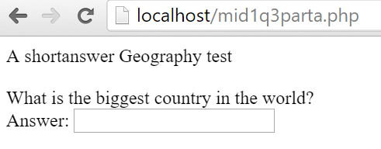

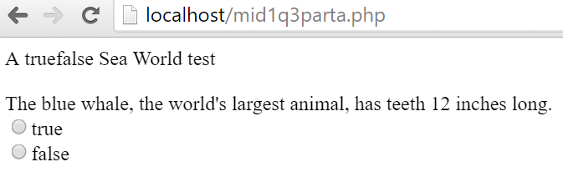

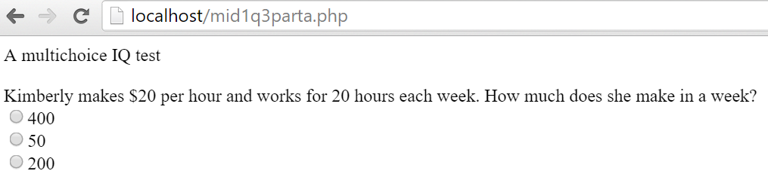

Q3b)

Second question part: PHP file

<?php

// getting the json file

$data = file_get_contents('shortanswerJSON.json');

$json = json_decode($data,true);

// get in this loop if the question type is either multichoice or truefalse

if ($json['Question'][0]['type']=="multichoice" or $json['Question'][0]['type']=="truefalse") {

//print question name and the question itself

echo "A ".$json['Question'][0]['type']. " " . $json['Question'][0]['name']. "<br><br>";

echo $json['Question'][0]['questiontext']."<br>";

//displaying answers

foreach($json['Question'][0]['answers'] as $item) {

echo "<input type='radio' id=" .$item['fraction'] . " name='multi' value =". $item['text'] .">".$item['text']."<br/>";

}

echo "<input type='submit' onclick='seeResult()'>";

}

// get in this loop if the question type is a shortanswer

else if($json['Question'][0]['type']=="shortanswer")

{

//displaying textbox for writing your answer

echo "A ".$json['Question'][0]['type']. " " . $json['Question'][0]['name']. "<br><br>";

echo $json['Question'][0]['questiontext']."<br>";

//create nodes in javascript with short answer possible answers

foreach($json['Question'][0]['answers'] as $item) {

echo "<SA type='hidden' id=". $item['text'] .">";

}

echo "Answer: <input type='text' id='ans' name='ans'>";

echo "<input type='submit' onclick='seeResultSA()'>";

}

// get in this loop if any other question type is given

else

{

echo "This type of question is not supported";

}

//get reult back after processing from javascript

$value = $_REQUEST["result"];

?>

Second question part: JavaScript file

<!DOCTYPE html>

<html>

<body>

<script type="text/javascript">

// calling the function for ajax

Result();

// a variable i use to store inofrmation whether the answer is correct or not

var correct;

// getting data from php in forms of html tags

function Result()

{

var xmlhttp = new XMLHttpRequest();

xmlhttp.onreadystatechange = function(){

if (xmlhttp.readyState == 4 && xmlhttp.status == 200) document.write(xmlhttp.responseText);

}

xmlhttp.open("GET", "mid1q3php.php", true);

xmlhttp.send();

}

// this functions handles calculation of result for multichoice and trufalse questions (called from php submit tag which i get using ajax)

function seeResult()

{

// the id is equivalent to the fraction of the particular answer in xml (either 0 or 100)

if(document.getElementById('100').checked) {

window.alert("your answer is correct");

correct = true;

}else {

window.alert("your answer is wrong");

correct = false;

}

sendResult();

}

// this function handles calculation of result for shortanswer (called from php submit tag which i get using ajax)

function seeResultSA()

{

// for shortanswer multiple solutions are accepted, I check if the input text field matches any of the correct possible answers

var all = document.getElementsByTagName("sa");

for(var i = 0, max = all.length; i < max; i++)

{

if(all[i].getAttribute("id")==document.getElementById("ans").value)

{

window.alert("your answer is correct");

correct = true;

}

}

if(correct!=true)

{

window.alert("your answer is false");

correct = false;

}

sendResult();

}

//called to send result back to php server

function sendResult()

{

var xmlhttp = new XMLHttpRequest();

xmlhttp.open("GET", "mid1q3php.php?result=" + correct, true);

xmlhttp.send();

}

</script>

</body>

</html>

True or false JSON file (same as question 1 part)

{"Question": [

{

"type":"truefalse",

"name":"Sea World test",

"questiontext":"The blue whale, the world's largest animal, has teeth 12 inches long.",

"answers":[{"fraction":"0","text":"true","feedback":"Ooops!"},{"fraction":"100","text":"false","feedback":"Correct!"}]

}

]}

Multiple choice JSON file (same as question 1 part)

{"Question": [

{

"type":"multichoice",

"name":"IQ test",

"questiontext":"Kimberly makes $20 per hour and works for 20 hours each week. How much does she make in a week?",

"answers":[{"fraction":"100","text":"400","feedback":"Correct!"},{"fraction":"0","text":"50","feedback":"Ooops!"},{"fraction":"0","text":"200","feedback":"Ooops!"}]

}

]}

Short answer JSON file (same as question 1 part)

{"Question": [

{

"type":"shortanswer",

"name":"Geography test",

"questiontext":"What is the biggest country in the world?",

"answers":[{"fraction":"100","text":"Russia","feedback":"Correct!"},{"fraction":"100","text":"russia","feedback":"Correct!"},{"fraction":"100","text":"RUSSIA","feedback":"Correct!"}]

}

]}

Second question part: screenshots for each JOSN file

